Lab16

Lab 16: Serverless Application Development
• Objective: Build a serverless application using AWS Lambda, API Gateway, and DynamoDB.

Create a lambda function
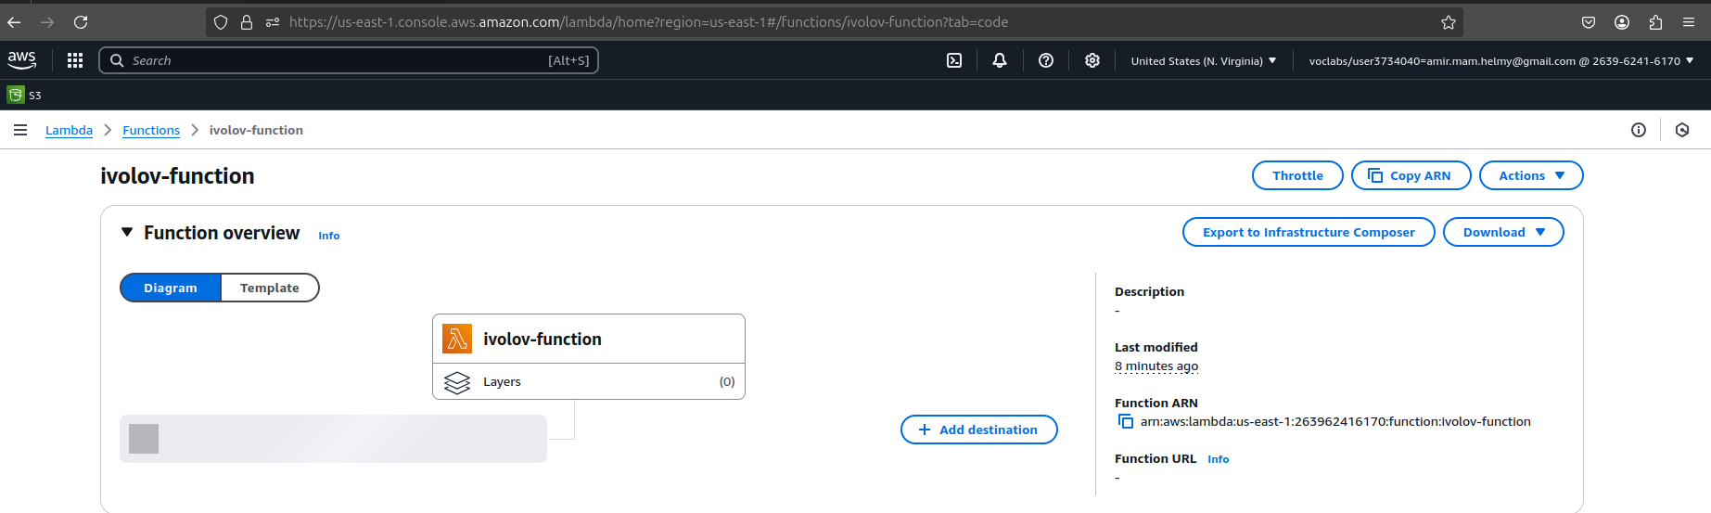

Create an API Gateway + create a resource + stage + integrate with the lambda function
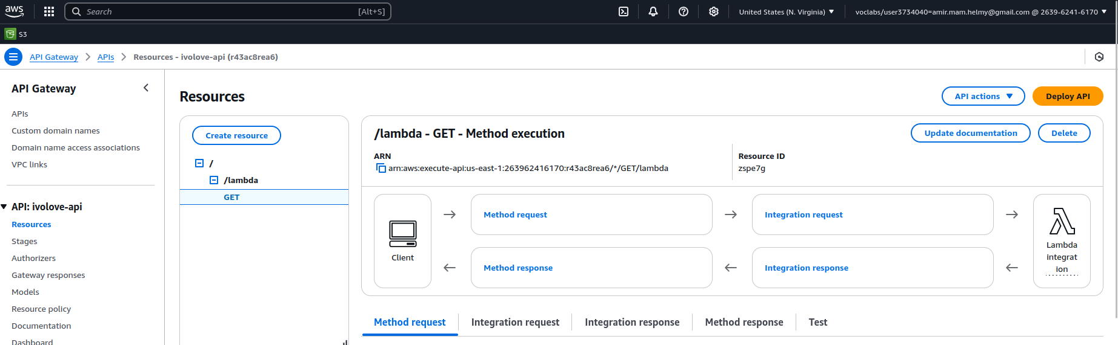
Deploy API

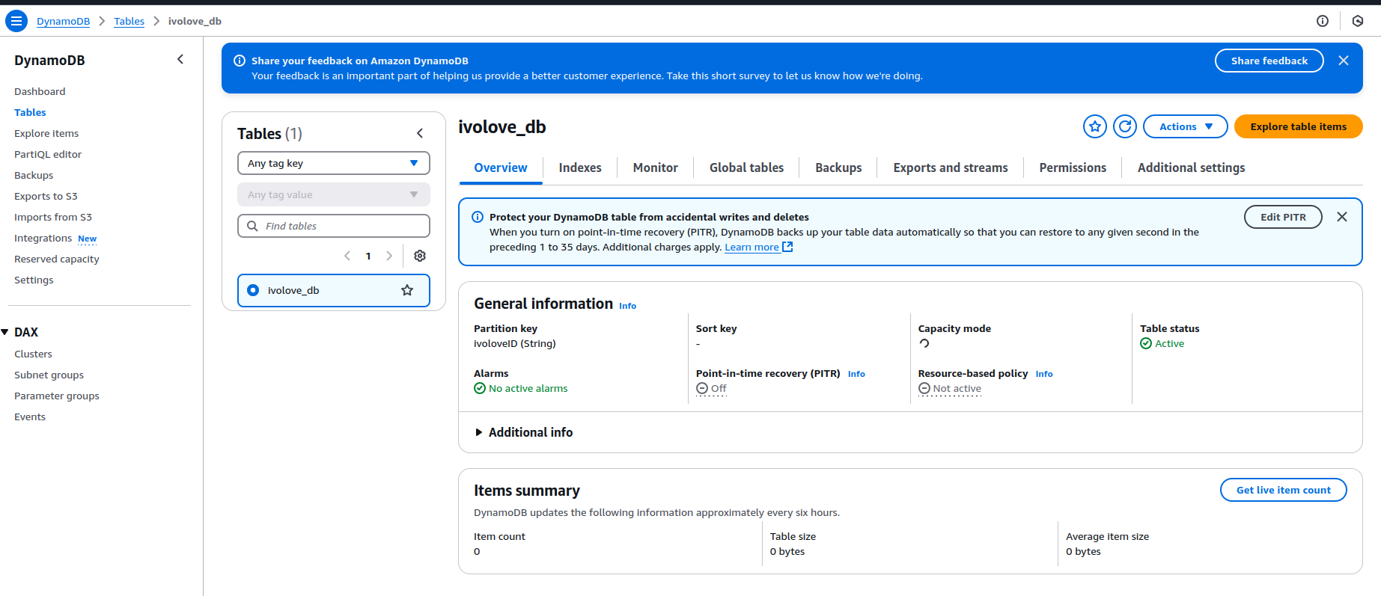
- Create a DynamoDB
- Give the Lambda function the appropriate role to connect to the DynamoDB
- After all, change code inside the lambda function to insert , update , delete items
